# **Fighting Time**

**Zoe's avatar**

[Zoe](https://substack.com/@zoeffc)

Nov 15, 2024

Share

Hey, hi, hello —

So I can accept that I don’t love all of my present circumstances. Mainly the political ones. I would love to see a woman elected in my lifetime but so far I have watched two brilliant women lose out to a felon and a rapist. Yea — I don’t love where things are politically.

Remember how I was telling you all a couple of weeks back that I exemplify several personality types that veer towards fighting?

If you haven’t already gotten there on your own, I would like you to join me in embracing that righteous fury (or whatever that looks like for you).

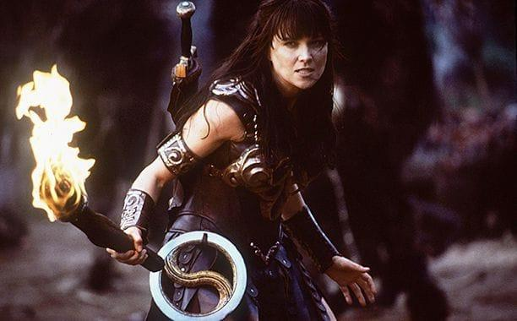

*Xena: Warrior Princess*

First some housekeeping:

📫 If a friend forwarded you this newsletter (then you have some really cool friends), and you may want to consider joining us here for regular updates.

[Subscribe](https://femme-futures.beehiiv.com/subscribe)

🧲 Got some thoughts you want to share? Join us on Discord to chat all things newsletter and corporate life.

[Discord](https://discord.gg/N84WxemQ?utm_source=femme-futures.beehiiv.com&utm_medium=referral&utm_campaign=fighting-time)

You can find all archived newsletters at the online site, if you ever want to go back or if you just feel like perusing.

[Check out the website](https://femme-futures.beehiiv.com/)

I am an activist by nature. By that, I mean that I get really pissed off by a world that has a habit of not living up to my expectations. Because of that pissed-off-ness, I crave action. Over the course of my life that has meant a number of things, from planning world domination at the tender age of six, to working for various nonprofits. This is how my fighting nature has made itself manifest.

You may not be a fighter. You may be a thinker or a feeler. My favorite people are thinkers and feelers. They are able to access parts of themselves that I lose when I go into fight mode. Luckily, an army needs a heart and a soul as much as it needs rage. So this is me inviting you in to use your skills, passion, and way of seeing things to help make this world a better place.

Femme Futures Cooperative is a space designed to foster the overachievers, the activists, and the world changers in a world which is terrified of them. The world is big. It’s fucking massive. You cannot fix it. You cannot turn back the clock, you cannot convince everyone to elect a sane person. You can, however, make a difference by fostering change in your communities.

If you are in the US, you can*:

* **Consider working in the nonprofit sector.** It makes me feel better when I wake up every day and know that my work is contributing to making the world better. There’s an added bonus of being made aware of just how many people are working to make this world better too.
* **Use resources to become more politically engaged.** Find low effort ways to contact your representatives. [I would seriously be in awe of you if you found a way to create more low effort political engagement resources]. Volunteer with organizations that are doing work that you find valuable.

If you are not in the US, you can*:

* **Put your money where your mouth is.** Donate or subscribe to causes, organizations, and individuals that you believe in. Things like journalism, human rights, abortion rights, and climate justice need financial support, especially as they lose support at the federal level. As someone who works in fundraising, I can tell you, even $5 a month makes a difference.
* **Support the betterment of your own communities.** I know that American politics are felt around the world. When you are not a voter in this democracy, it can feel crazy-making to watch this shit unfold. You are not helpless though. Address the issues that *your* community is facing. The US doesn’t like to be in last place. Remind us what is possible.

I think that the people reading this note are the people who will drive us into a brighter future. I think that when you can only imagine your future in greyscale, you have the strength inside of you to form the future to your will. It might take a lifetime — or several lifetimes. But your energy will not be for nothing.

When Hillary Clinton lost the 2016 election, I believed that this was the country telling me that the US is fundamentally misogynistic. I still believe that to a certain extent. After her defeat, her alma matter and it’s sister schools which foster women’s education saw massive upticks in applications year after year. Young girls were furious and ready to prove that they could be leaders. The #metoo movement was birthed from the rage that we elected a man who proudly assaults women to the presidency. That reactionary rage has caused massive social change, and it can do so again.

As I write this, I feel the need to point out that even with Seven Sisters application rates increases and #metoo (and the major advancements in women in c-suite roles and congress and the senate), we still re-elected Trump. The progress that I crave is not a fast moving one. It is rife with setbacks and disappointments. To manage them, I turn to my fighting instinct. I hope that you can turn to fight or to think or to feel.

You are a world changer.

If nothing else, let these weekly emails be a reminder that you are not facing these challenges alone.

Zoe

*these are not nearly the only options… please do what makes sense to you. These made sense to me.

🎤**Fighter Anthems that Make Me Bawl:**

* Quiet by MILCK
* The Kids are All Rebels by Lenii
* Us and Pigs by Sofia Isella

**Femme Futures Cooperative Founding Principles**

💚 **Mission**: The mission of Femme Futures is to create a community space for young professionals who identify as over-achievers and activists to generate collective success by providing resources and platforms to thrive in challenging workplace environments.

💙 **Vision**: To contribute to a world where driven individuals are equipped with the tools, guidance, and connections to overcome systemic barriers, fully utilize their talents, and enact positive change in their organizations and communities.